



**Intellectual Property Management Plan**

**February 28, 2011**

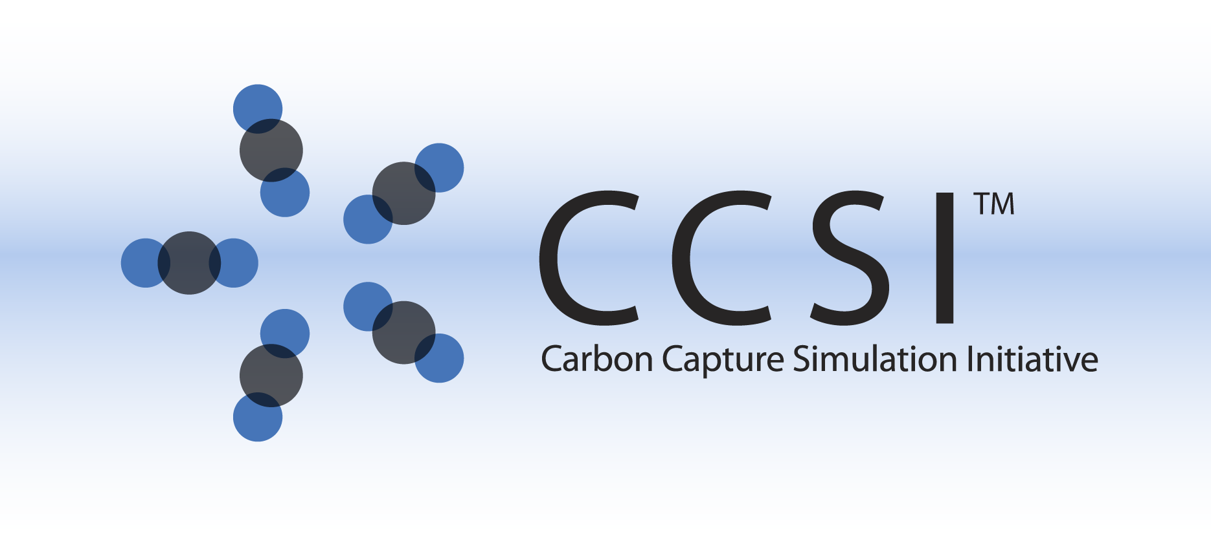

iREVEAL USER MANUAL

Version 2014.06.24

June, 2014

This Material was produced under the DOE Carbon Capture Simulation Initiative (CCSI), and copyright is held by the software owners: ORISE, LANS, LLNS, LBL, PNNL, CMU, WVU, et al. The software owners and/or the U.S. Government retain ownership of all rights in the CCSI software and the copyright and patents subsisting therein. Any distribution or dissemination is governed under the terms and conditions of the CCSI Test and Evaluation License, CCSI Master Non-Disclosure Agreement, and the CCSI Intellectual Property Management Plan. No rights are granted except as expressly recited in one of the aforementioned agreements.

Table of Contents

1. Introduction 1-1

1.1. Motivating Example 1-1

1.1.1. Overview 1-1

1.1.2. Supported Features 1-2

1.2. Restrictions 1-3

2. Tutorial 2-3

2.1. Setup Reduced Order Model Configuration 2-3

Description 2-3

Examples 2-3

Steps: 2-3

2.2. Build ROM 2-3

Description 2-3

2.3. Export ROM 2-4

Description 2-4

Steps: 2-4

3. Usage Information 3-4

3.1. Support 3-4

3.2. Restrictions (if any) 3-4

3.3. Recent Changes (optional) 3-5

3.4. Next Steps (optional) 3-5

4. Advanced Features (if appropriate) 4-5

5. Debugging 5-5

5.1. How to Debug 5-5

5.2. Known Issues 5-5

5.3. Reporting Issues 5-5

6. Appendix 6-5

# Introduction

The iREVEAL framework is a generic reduced order modeling tool that provides a command line interface to build a reduced order model (ROM), given a high-fidelity model. For the Carbon Capture Simulation Initiative, the tool has been configured with capabilities to process any CFD model (MFIX, Barracuda, Fluent), and supports other CFD specific requirements. We discuss the generic reduced order modeling process for completeness, followed by the details on each step and features available in the iREVEAL toolkit in the following sections.

## Motivating Example

A user trying to integrate a high-fidelity model into a larger system level simulation, can use this tool to create an approximate surrogate model that runs in O(1) time. The generated surrogate model is in a compliant ACMF or Cape Open format and can be directly integrated in the system level simulation.

Another use case for iREVEAL is to simply study model under varying conditions. For e.g: A typical CFD model takes a week to run and reach steady state. If the user has already studied this model under 10 different conditions before and has that data, it can use the already generated data to create a reduced order model” using iREVEAL and use it to get a reasonable idea on the output parameter values to be expected by running the CFD model on other variation of input parameter set, overall saving significant time.

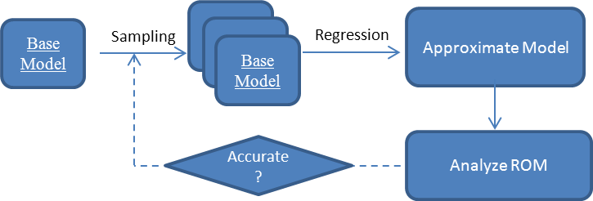

## Overview

The basic concept of model reduction assumes that the input-output relationship from a computationally expensive simulation can often be well approximated by a much lower dimensional, computationally inexpensive model that gives nearly the same output response. Generating a ROM requires generating and analyzing multiple instances of the simulation under varying conditions, so the overall behavior of the system can be reasonably approximated. As the design of the ROM Builder framework is deeply driven by the generic workflow required to build a reduced order model, we discuss the generic process of creating ROM next.

ROM creation is a multi-stage process, driven by a scientist who has a deep understanding of the computational model. As shown in Figure 1, the steps are as follows:

1. Select a base case simulation model and specify which input parameters and output values of this model should be represented in the ROM.
2. Select a sampling method that generates N possible values for all the selected input parameters within ranges specified by the scientist. This produces N distinct input files for the simulation, each with a different set of values for the input parameters of interest.
3. Execute an ensemble of simulations, one for each input sample set generated by the sampling algorithm. This step can take days to weeks depending on the simulation time, the number of samples, and the computational resources available.
4. Choose and execute a regression method to generate a response surface that maps simulation inputs to the outputs from the ensemble runs.
5. Analyze the response surface and quantify the accuracy of the ROM.
6. Use iterative approaches to improve the ROM accuracy by incorporating new samples.



Figure 1 : Reduced Order Modeling Process

1. Export Reduced Order Model for integration in larger scale ‘system’ simulations.

## Supported Features

iREVEAL toolkit provides all the major set of features needed to generate a ROM, from any CFD model. The features available are:

1. Generate Samples for input parameter space: A user can select any input parameters and generate samples using any of the following sampling methods:
   1. *Latin Hypercube Sampling* : Generates a uniform sample in the parameter space
   2. *Normal Distribution Sampling* : Generates a Gaussian distribution of samples, with samples centered around mean value of the parameter.

mean = (min + max)/2

Standard_deviation = (max-min)/7

* 1. *Quasi Monte Carlo Sampling* : Users can select from Halton, Sobol or Torus sequence to generate samples.

1. Build ROM and Export ROM file: Once the results of all simulations become available , “Build ROM” can be invoked. The framework invokes the selected regression method and creates the mapping between input parameters and output parameters.
2. Export ROM as ACM or CapeOpen format: The user will have the option to export ROM as ACM or in CapeOpen format, after they have build ROM using Kriging. This will generate a ACM.acmf or CapeOpen.out file which can then be used to integrate ROM in a process simulation.

## Restrictions

The iREVEAL framework is intended to be used for creating ROM for Computational Fluid Dynamics Models.( MFIX/Barracuda/ Fluent/ Other)

# Tutorial

For the purpose of the tutorial, we will consider that the input files containing the CFD data has been placed under directory *$work_dir*, where *$work_dir* denotes the complete path ( not just relative path) to this directory

## Setup Reduced Order Model Configuration

### Description

To set up the initial configuration of the ROM: input parameters to the ROM and their ranges, and number of samples.

File to configure : *“$work_dir /elec.json”*

### Examples

The user will provide all the configuration data for ROM in a json file. We have included a sample input file under examples directory in iREVEAL release :*“examples/elec.json”* file.

To create samples, using sampling method = LHS or QMC or Normal.

Input file : “*$work_dir /elec.json*”

Output file : *“$work_dir /rom.in”*

Sampling_Method Options= LHS(default), QMC-H, QMC-T, QMC-S, Normal

### Steps:

Running iREVEAL:

1. Open command line in windows
2. java -jar “complete_path_to_iReveal.jar” –s “Sampling_Method”

-i *“complete_path_to_input_json_file*”

e.g. : java –jar “C:/users/me/ireveal/iREVEAL.jar -s LHS –i “C:/users/me/ireveal/examples/elec.json”

**Step Output :**

On successful execution should generate *“$work_dir /rom.in”* file. The “rom.in” file contains values of sampled parameters, one simulation per line in tab separated format. This step also generates 3 temporary files in *$work_dir*: a) *“param.in”*, b) *“ACM_code.acmf”*, c)*“CapeOpen.rom”.*

All the 4 files generated in this step will be used in subsequent steps to build reduced order model and create the export files in Cape-Open and ACMF complaint format.

## Build ROM

### Description

For doing regression and create mapping of input to output space

**Example**

Once the results of all CFD runs is available. User creates a “*results*” file in *$work_dir*

containing values of all output parameters . The format of “*results*” file should be same as “*rom.in*”. ( 1st line contains name of output parameters separated by tab or space. For each simulation the results are listed one per line. Output parameter values are separated by a space or tab.)

Note :

1)The order in which simulations results are listed in *“results”* should be same as provide in “*rom.in*”. Line 1 contains results for simulation1. Line 2 contains results for simulation2 and so on.

2) The order or resulting values should be same as in “elec.json” under Output_Parameter section.

User can select any output parameters that can be calculated from the CFD output files directly. The user also needs to select a regression method that should be used to create mapping between the input parameters and each of the output parameters. The version 0.1 supports “Kriging” regression method.

**Steps**:

1. Open command line in windows
2. Java -jar “complete_path_iReveal.jar” -r *“$work_dir/results”* –d *$work_dir*

**Step Output :**

On successful execution should generate *“$work_dir /Kriging/”* directory. The “errors” file under this directory contains mean error values after N-fold cross validation test. The “predicted_results” file in this directory (same format as “$work_dir/results” file) contains predicted values of output parameters (one simulation per line) using the reduced order model.

## Export ROM

### Description

For creating the ACMF compliant or Cape Open compliant file for the CFD ROM:

### Steps:

1. Open command line in windows
2. Java -jar “complete_path_iReveal.jar” -e *$work_dir*

**Step Output :**

On successful execution should generate *“$work_dir /model.ACMF” and “$work_dir /model.CO” files.* These files are reduced order model file files for CFD data , which are ACMF and Cape-Open compliant respectively.

# Usage Information

## Support

send an email to [ccsi-support@acceleratecarboncapture.org](mailto:ccsi-support@acceleratecarboncapture.org) for any issues.

## Restrictions (if any)

This software is currently intended to be used for CFD model

## Recent Changes (optional)

## Next Steps (optional)

Support for model input file generation and output data processing for Barracuda and Fluent.

# Advanced Features (if appropriate)

The advanced features have been described in the appropriate subsections of section:2 (Tutorial)

# Debugging

Provide users with an explanation of how to check that the software is working correctly or handle cases where things are not working as expected.

## How to Debug

The user may experience issues with installation , they should do installation checks mentioned in installation manual. If user experiences problem they should

1. **Send Python.log file from the directory you are running command line from:**

User can go to directory where they are running command line from and send the python.log file to the support team.

1. Send the message on the command line screen

## Known Issues

If the user does not provide complete path to$work_dir and uses relative path instead it creates problems, running the code.

## Reporting Issues

To report an issue please send an email to [ccsi-support@acceleratecarboncapture.org](mailto:ccsi-support@acceleratecarboncapture.org)

# 

# Appendix

**Terms:**

* + CFD – Computational Fluid Dynamics
* MFIX – Multiphase Fluid Interphase Exchange : <https://mfix.netl.doe.gov/>
* ACMF – Aspen Custom File Format
* CO – Cape Open
* Model - A new computational Fluid Dynamics model built for MFIX simulator
* ROM - Reduced Order Modeling